**Group B-1 Project 1**

**Project Title:** Spotify Predictors

**Team Members:** Harsha Vinoy, Kaixin Yang,William Powell, Connor Scherer

**Description:**Analyze music data in order to be able to make a prediction about future hits in the US and globally.

**Main Questions:**

* How do music trends compare between different countries around the world?
* Analyze the most popular songs and artists specifically in the US throughout recent years on Spotify.
* How does Spotify data compare with The Billboard Hot 100?
* Can data of past hit songs be used to make a hit song “formula”?

**Datasets:**

* <https://www.kaggle.com/yamaerenay/spotify-tracks-dataset-19222021?select=US.csv>
* <https://www.kaggle.com/dhruvildave/spotify-charts?select=charts.csv>
* <https://www.kaggle.com/leonardopena/top-spotify-songs-from-20102019-by-year>

**Breakdown of Tasks:**

* Find datasets
* Merge datasets if necessary
* Cleanup data
* Create dataframes
* Create plots
* Create presentation

**Summary**

**Questions:**

* How do music trends compare between different countries around the world?
  + Music trends are globally universal as evident in Figures 1 & 2.
  + Because of this we can look at just the US and extrapolate outward.
  + Danceability and Energy are at an intersection, see Figure 3.
  + The top songs as a whole seem to be getting simpler over time (Fig 4.)
    - The songs are getting shorter, more stable, and have less range
  + Overall popularity seems to be accumulating into fewer songs over time. (Fig 5)
    - The top few songs are getting an increasingly disproportionate amount of listens

* What are some of the most popular songs and artists trends specifically in the US throughout recent years on Spotify?
  + The chart of “top 10 popular songs in the U.S. on Spotify over the last five years ” (Figure 6) is based on the number of audio streams. In the top 10 songs, the second song is a Pop song, and the other 9 songs are Hip-Hop songs.Drake and Olivia Rodrigo both had over 5 million streams, while the next highest was Lil Wayne. It is clear that Drakeis a huge front runner in the popularity contest based on this dataset.
  + The chart of “ top 10 artists in the U.S. on Spotify over the last 5 years” (Figure7 ) counts the frequency that an artist appeared on the "Top 200" charts in the U.S.. 8 of 10 artists in this bar chart are rappers, and the other 2 artists (Taylor Swift and Ariana Grande) are pop stars.
  + From these charts, we think the most popular genres in the US are hip-hop and pop music over the last 5 years.
* How does Spotify data compare with The Billboard Hot 100?
  + The billboard rankings take into account the sales, radio plays and online streaming of a song to determine the ranking where popular songs in Spotify are determined using the number of streams.
  + By looking at the Billboard data, the top genres from 2017 to 2019 in the US mostly fall under the pop category. Dance pop takes the lead as the number one highest genre count that appeared in the Billboard rankings based on Figure 8. This is different to Spotify's top genres where hip hop or rap songs were taking the lead in the Spotify charts.
  + The top artists are also different when it comes to Billboard rankings and Spotify rankings. From 2017 - 2019, the top artists that had the highest count of appearance on the billboard charts were mostly pop artists based on figure 9 and figure 10.
* Can data of past hit songs be used to make a hit song “formula”?
  + Based on all the findings, the music trends are similar in all the 5 countries by analyzing the danceability and energy changes over time. It’s safe to assume that music trends around the globe are universal, therefore, looking specifically at US data could help in predicting the next global hit.
  + Based on uS Spotify data, hip-hop and pop genre songs and artists have higher popularity in the Spotify charts. This is different from US Billboard data where pop genre songs and artists are leading the rankings.
  + For the next global hit song, our data suggests that a song or an artist from the dance pop genre would become the next global popular song and rank highest in any music charts in the world. This is based on how danceability is increasing globally and in the US (Fig. 1 & 3) and how pop songs are leading the rankings in Spotify and Billboard charts.

**Figures:**

**1: Danceability vs Year**

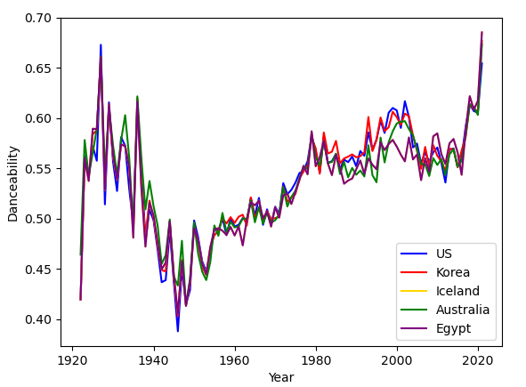

**2: Energy vs Year**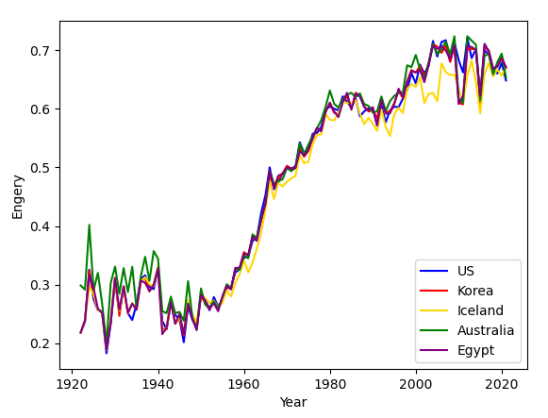

**3: US Danceability vs Energy**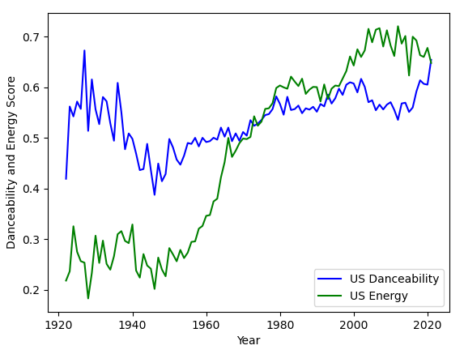

**4:Qualities of hit songs (2010 - 2019)**

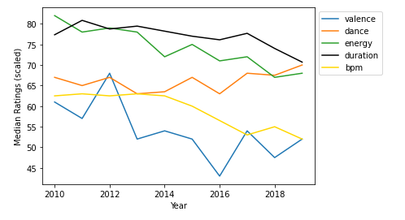

**5: Median popularity rating of the top songs (2010 - 2019)**

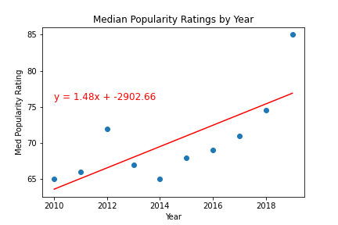

**6:Top 10 songs of US (2017 - 2021)**

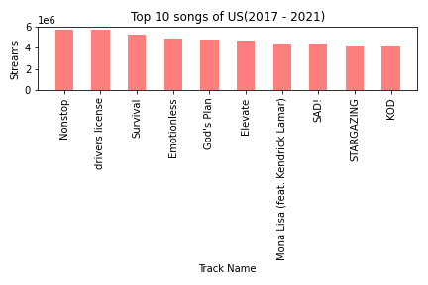

**7: Top 10 artists of US (2017 - 2021)**

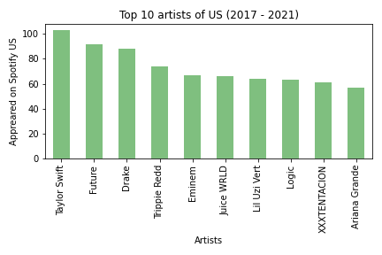

**8: Top 10 Genres on the Billboard (2017 - 2019)**

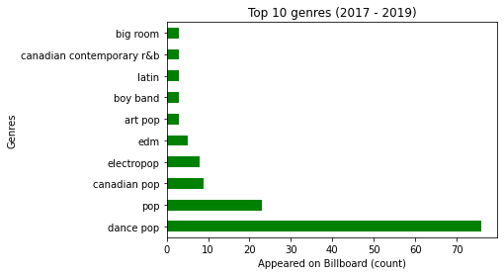

**9: Top 10 Artists on the Billboard (2017 - 2019)**

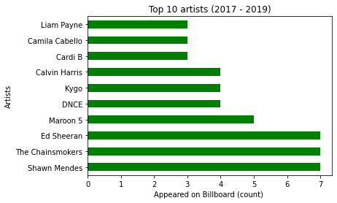

**10: Top Genres of the top 10 Artists on the Billboard (2017 - 2019)**

